**Instructions for Student BEAS State Registry Check**

1. **Select the link to initiate the BEAS Registry Check Consent Form:** [**https://powerforms.docusign.net/572b4ad4-aa00-48ad-a659-1c51b01b8abd?env=na3&acct=218a4fcb-16f9-4e09-866c-c789e5885d61&accountId=218a4fcb-16f9-4e09-866c-c789e5885d61**](https://powerforms.docusign.net/572b4ad4-aa00-48ad-a659-1c51b01b8abd?env=na3&acct=218a4fcb-16f9-4e09-866c-c789e5885d61&accountId=218a4fcb-16f9-4e09-866c-c789e5885d61)

**2. Complete the PowerForm Signer Information:**

* **Use your own name or your school advisor/professor and your/school email**
* **Use your name and email as the prospective employee**

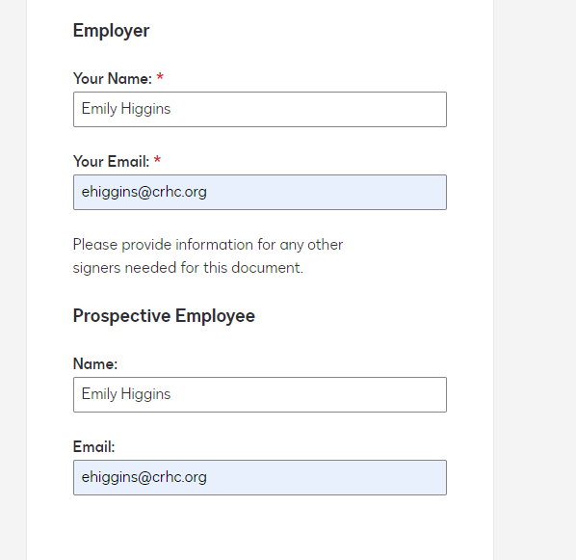

1. **Accept the Electronic Record and Signature Disclosure**

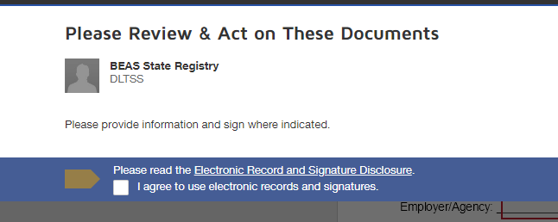

1. **Complete the Information in the top box and select finish**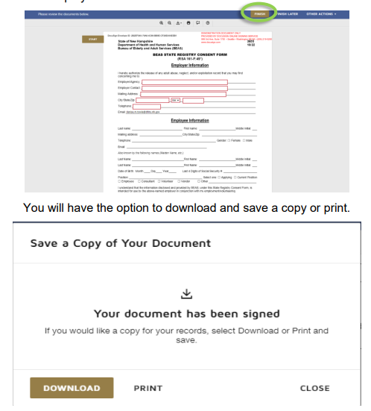
2. **Follow the instructions to complete the registry and run the results:**[**https://www.dhhs.nh.gov/sites/g/files/ehbemt476/files/documents2/beasregistryemployeeinstruction.pdf**](https://www.dhhs.nh.gov/sites/g/files/ehbemt476/files/documents2/beasregistryemployeeinstruction.pdf)
3. **The form will come back to you once the state completes it, you will need to download and save it.**
4. **Send the form with the rest of your completed paperwork to** [**ehiggins@crhc.org**](mailto:ehiggins@crhc.org)